Better As a Memory
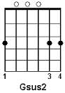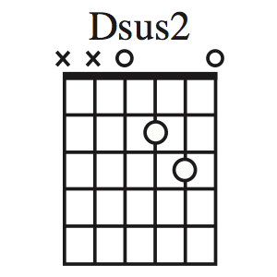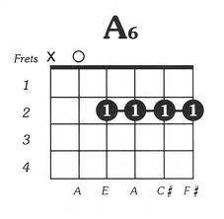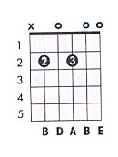
Bm11

Intro Dsus2 A/C# Bm11 Gsus2 (X2)

I move on like a [Dsus2] sinner's prayer. Let 'em go like a [A6/C#] levee breaks. Walk away as if [Bm11] I Don't care.
Learn to shoulder my [Gsus2] mistakes. I'm built to fade like your [Dsus2] favorite song, gettin' reckless when there's [A6/C#] no
need. Laugh as your stories[Bm11] ramble on. Break my heart but it [Gsus2] won't bleed. My only friends are [Bm] pirates,
it's just who I [Asus] am [A] I'm [G] better as a mem-[A]-'ry than as [D] your man.

I'm never sure when the [Dsus2] truth won't do. I'm pretty good on a [A6/C#] lonely night. I move on the way a [Bm11] storm
blows through. I never stay, but then again [Gsus2] I might. I struggle sometimes to [Dsus2] find the words, always sure
until [A6/C#] I doubt. Walk a line un-[Bm11]-til it blurs. Build walls too high to [Gsus2] climb out. But I'm honest to [Bm]
a fault, it's just who I [Asus] am. [A] I'm [G] better as a mem-[A]-'ry than as [D] your man.

[G] I see you lean'in. [D/F#] You're bound to fall. [Asus] I don't wanna [A] be that mistake. { D Em F#m } [Gsus2] I'm
just a dreamer, [D/F#] nothin' more. [Em7]You should know before it gets to late. [Asus] [A] 'Cause goodbyes are like a
[Dsus2] roulette wheel, you never know where they're [A6/C#] gonna land. First you're spinnin; then you're [Bm11] standin'
still, left holdin a los-[Gsus2]-in hand. But one day you're gonna [Dsus2] find someone, right away you'll know [A6/C3] it's
true that all of your [Bm11] seek-in's done. It's just part of [Gsus2] the pass-in through. Right there in that [Bm] moment
you'll fin'lly under [Asus] stand [A] that I was [G] better as a mem-[A]-'ry than as [Bm7] your man, [Gsus2] [G] better as a
mem-[A]-'ry than as [D] your man.

Dsus A/C# Bm11 Gsus2 Dsus2 A/C# Bm11 Gsus2 Repeat and Fade

